**Computer Network Q&A**

1.Differentiate between packet switching and circuit switching

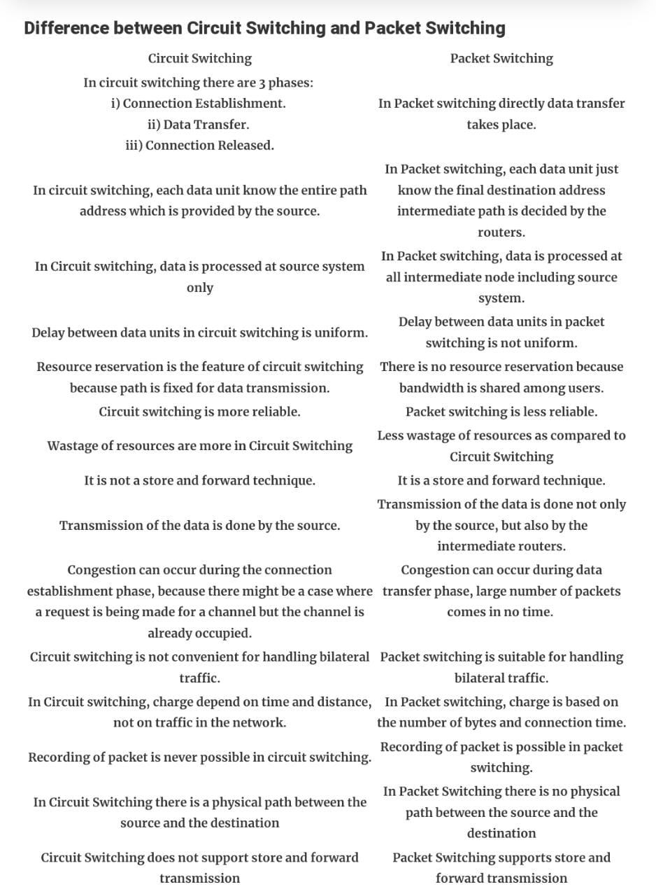

2. Compare the client server and P-to-P network architectures.

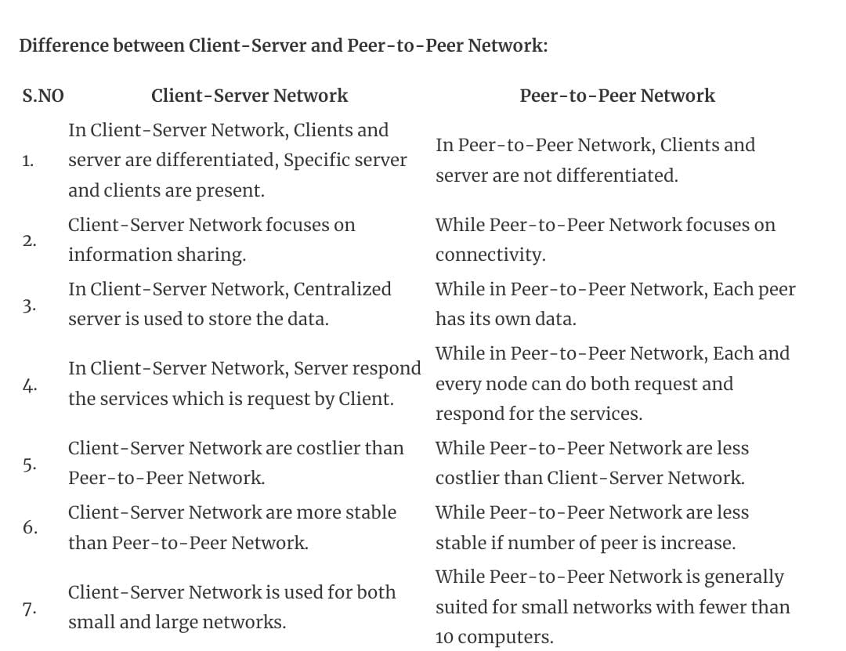

3. Differentiate between TCP service and UDP service.

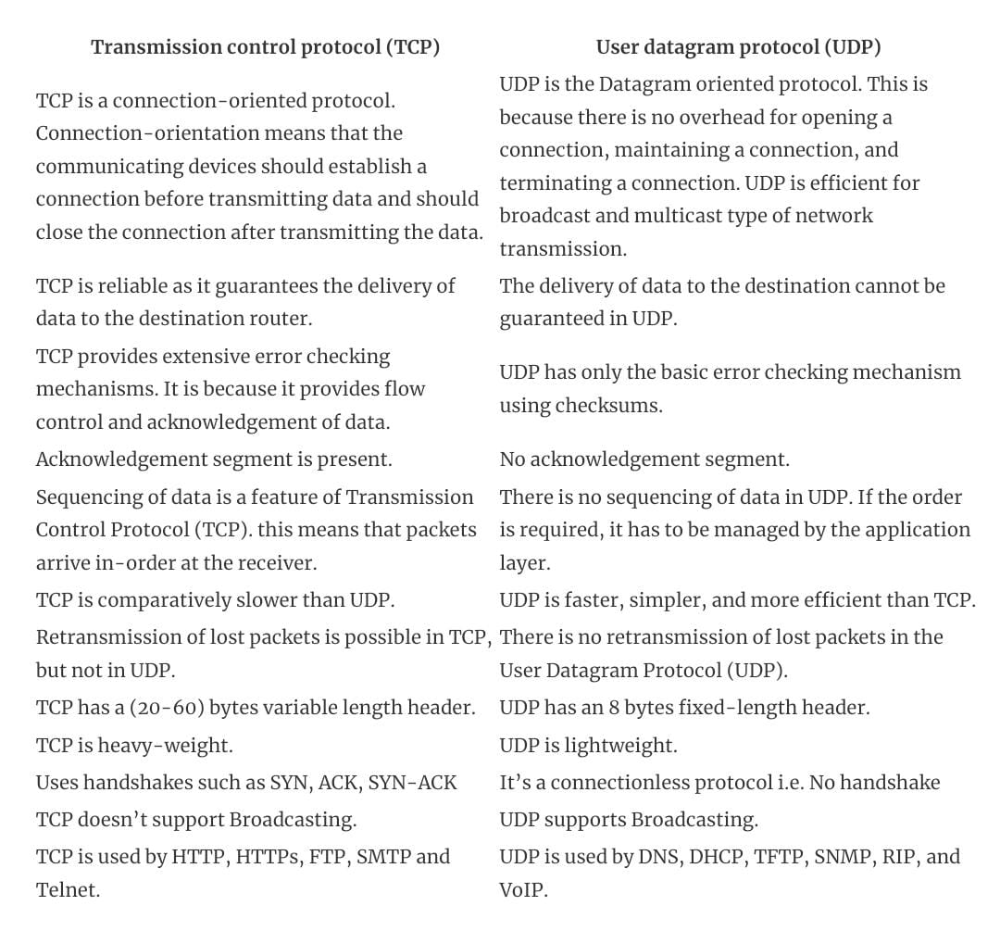

4. Explain the working of FTP along with sample responses and codes

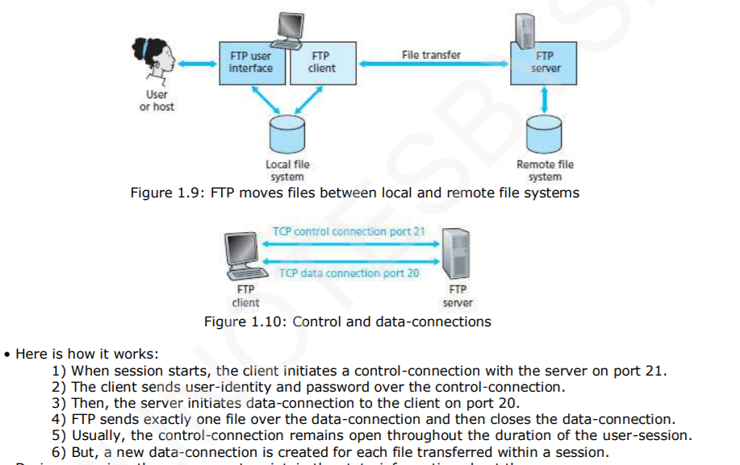

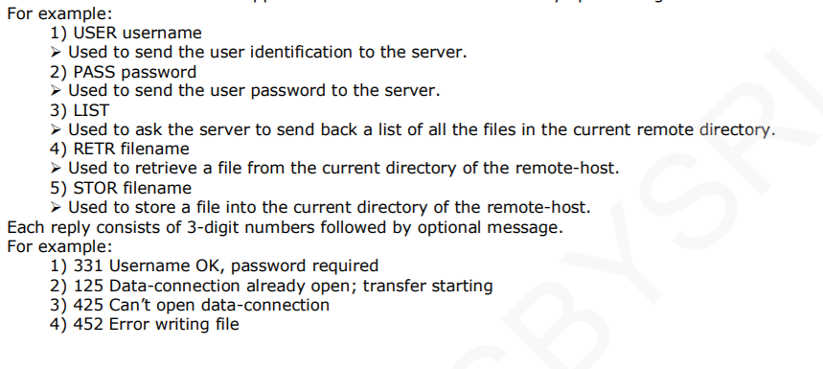

5. Explain stepwise non-persistent HTTP protocol.

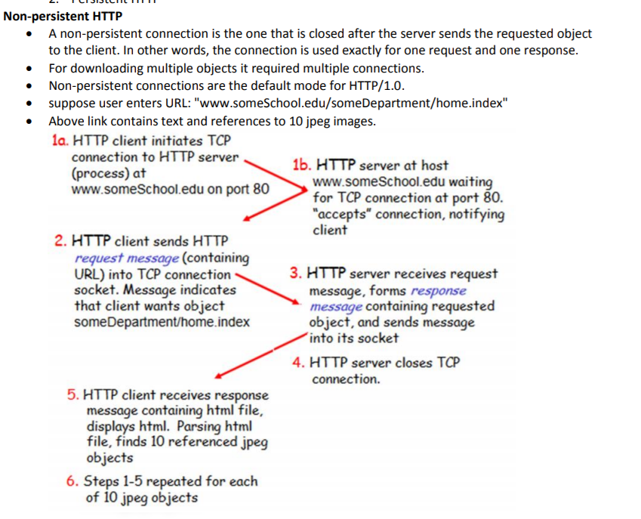

6. Apply working of P-to-P architecture for file distribution application Bit Torrent

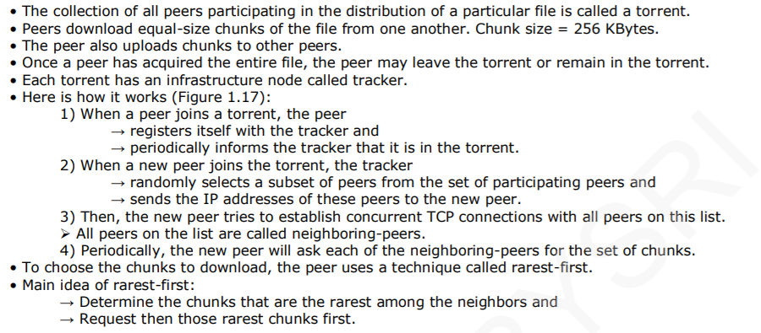

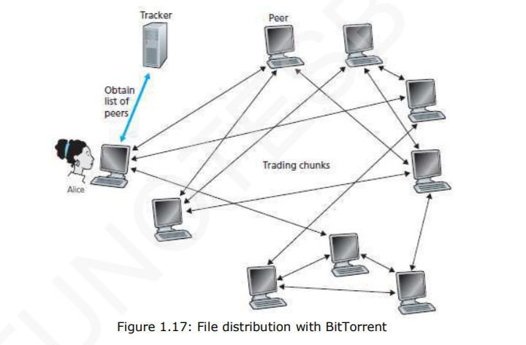

7. Demonstrate the interaction that happens in SMTP between A and B for sending and receiving the Emails

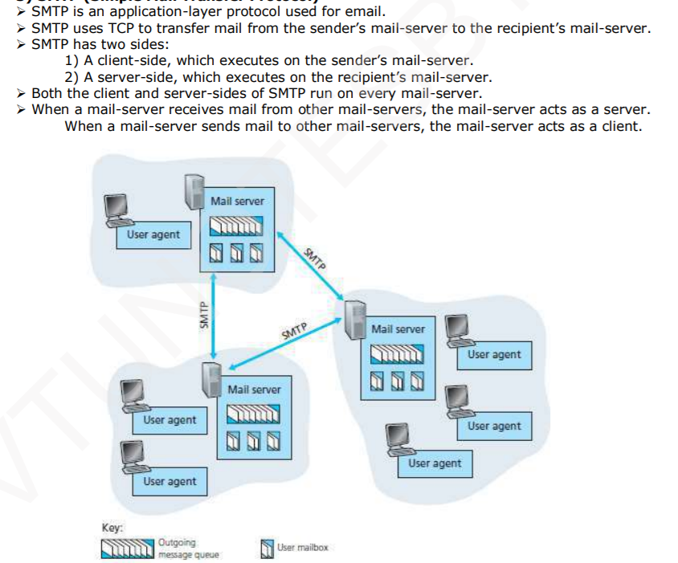

8. Demonstrate the Internet with an appropriate figure for the same having IXP, ISP access nets.

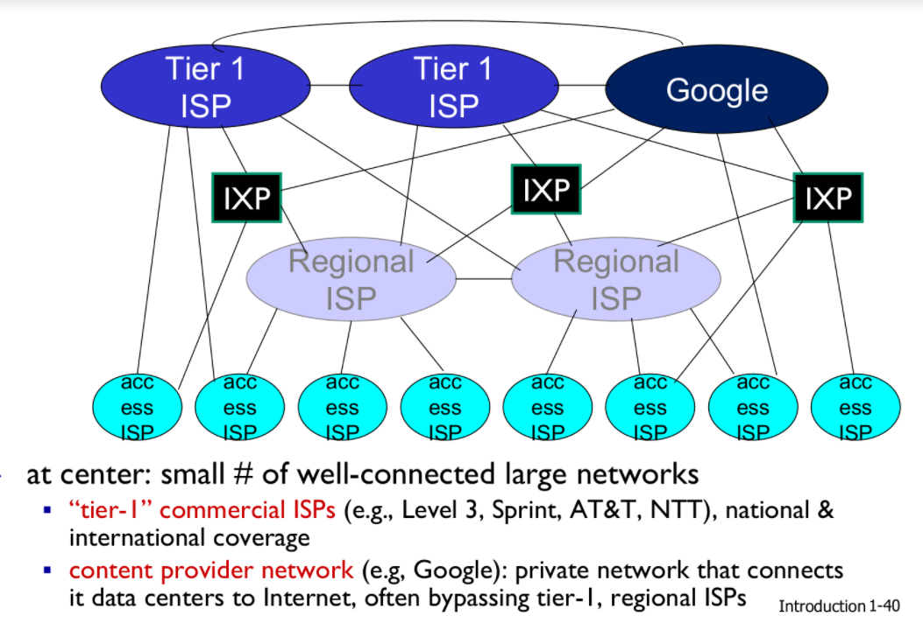

9. Explain the practically implemented network-model and list the functionalities of each of the layer.

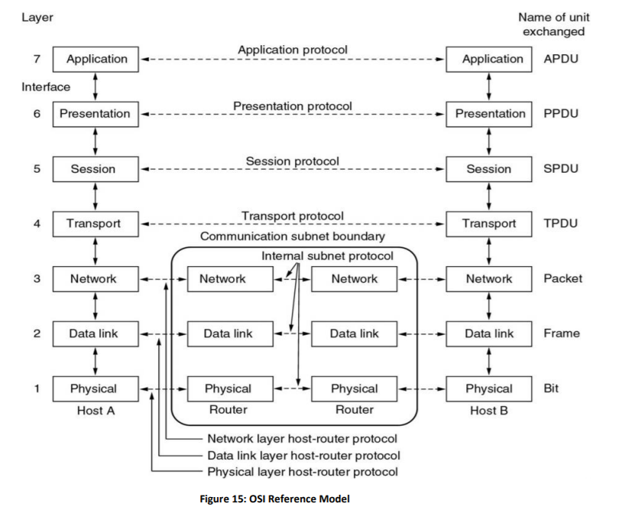

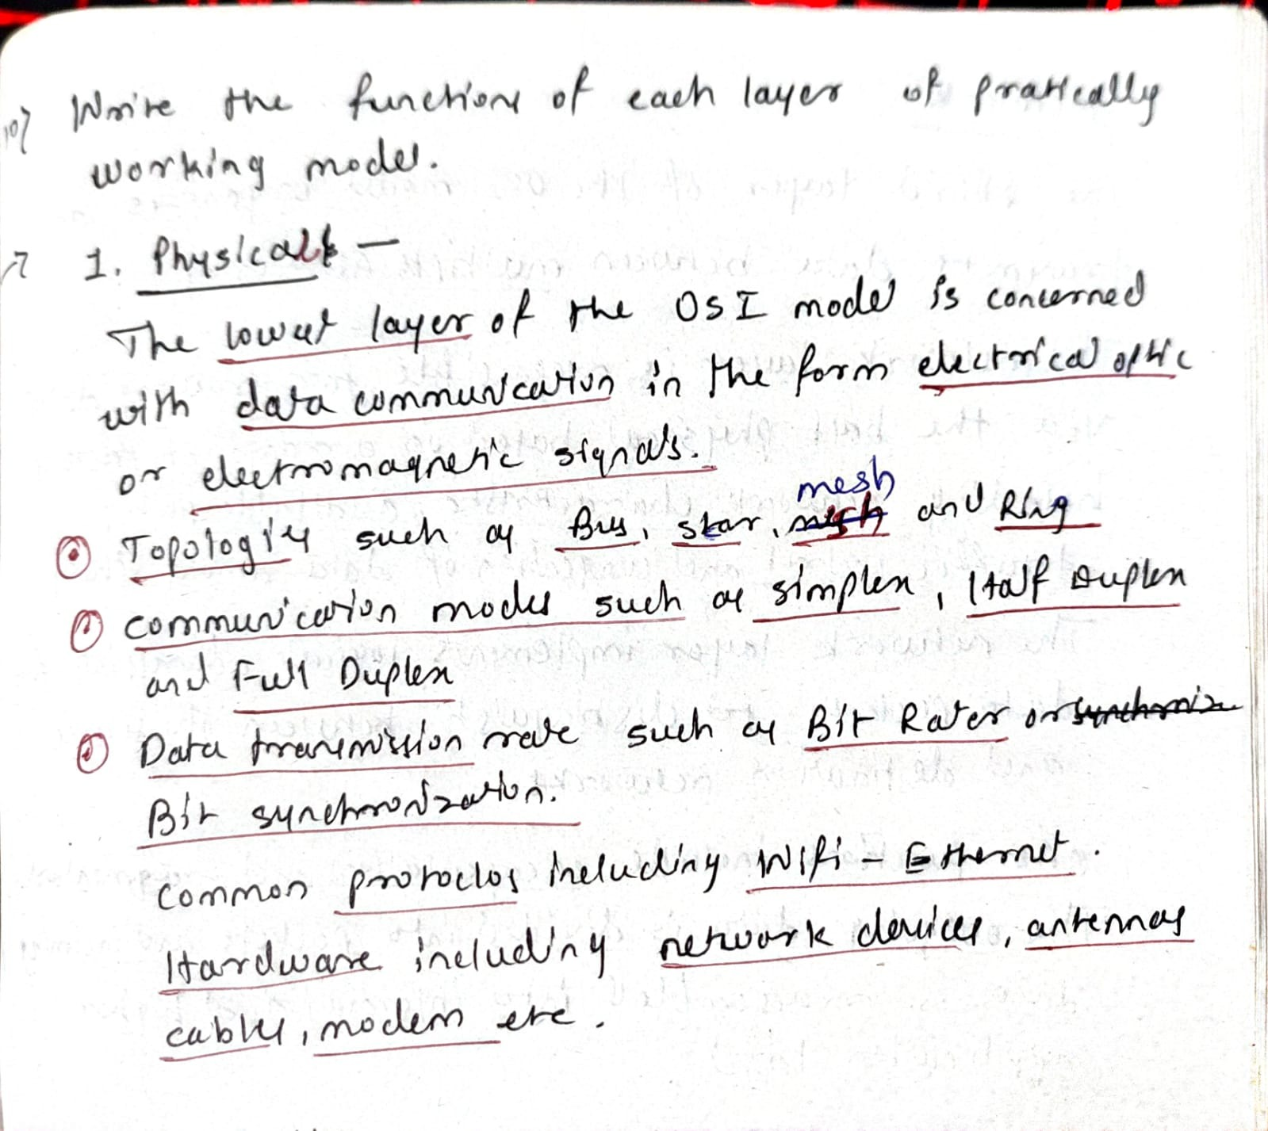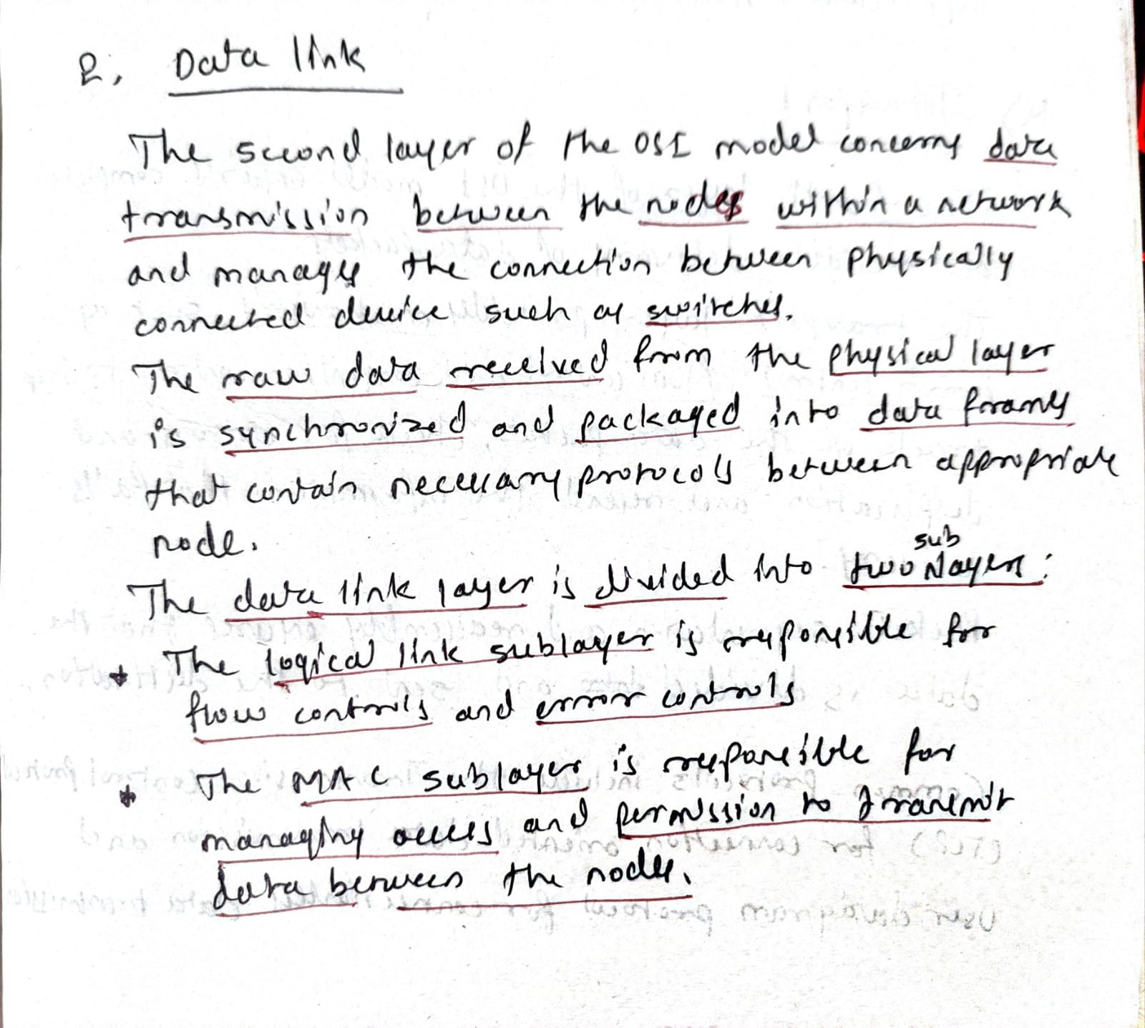

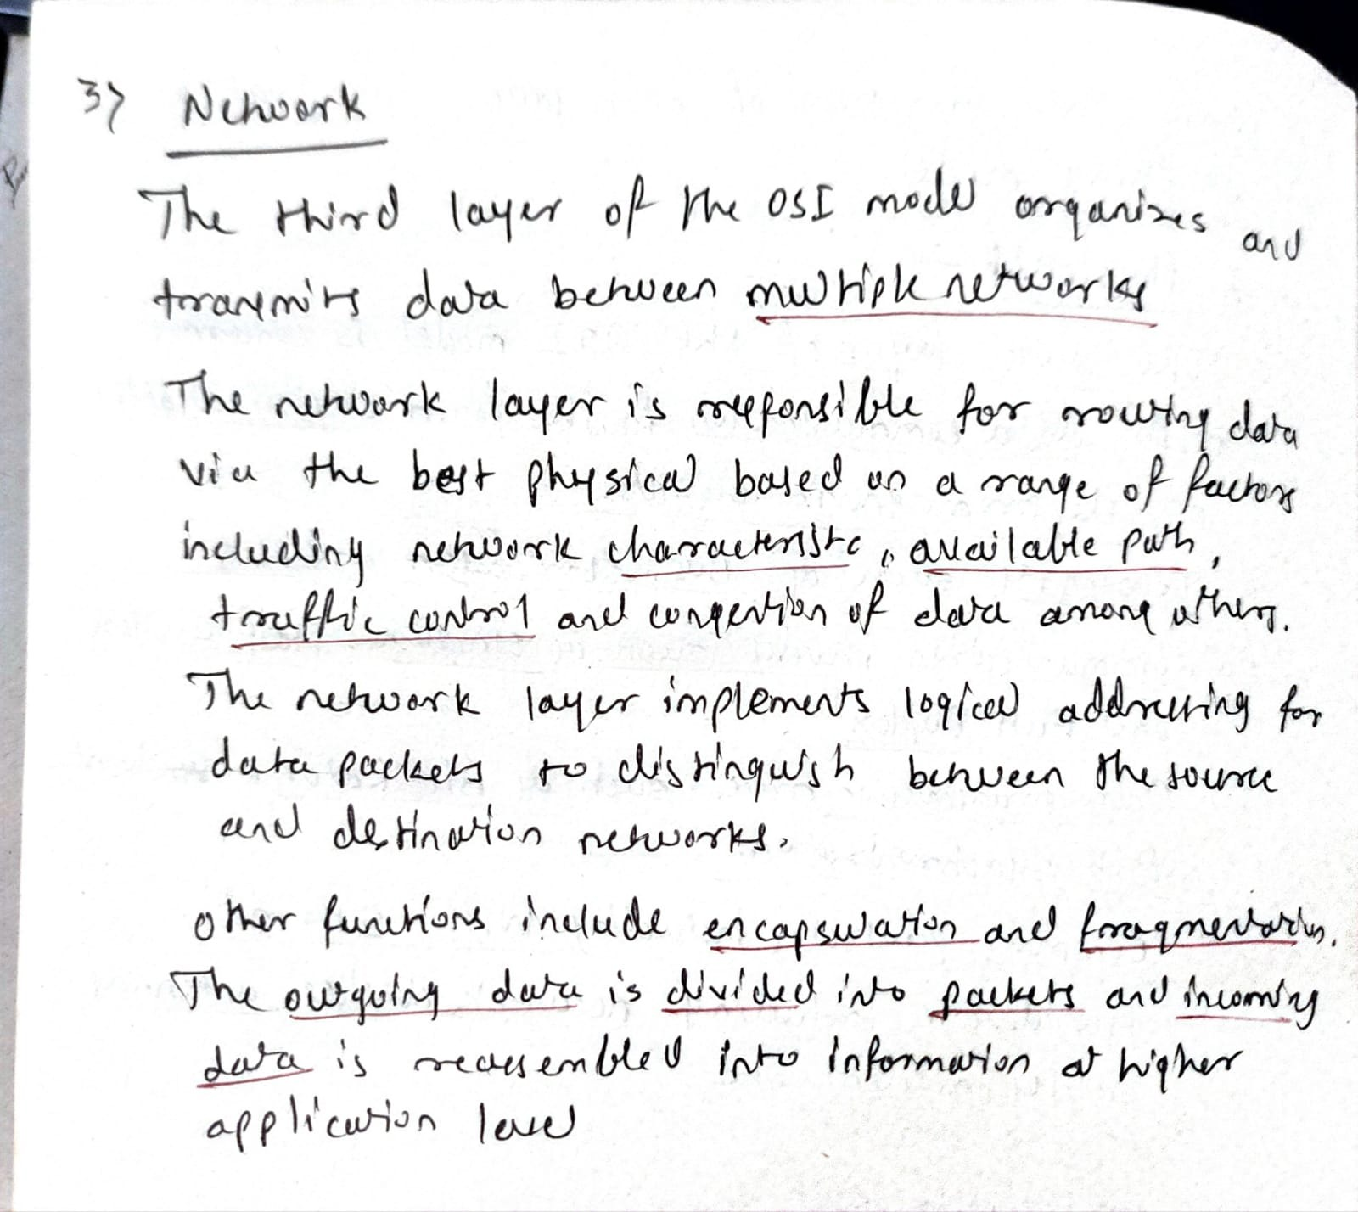

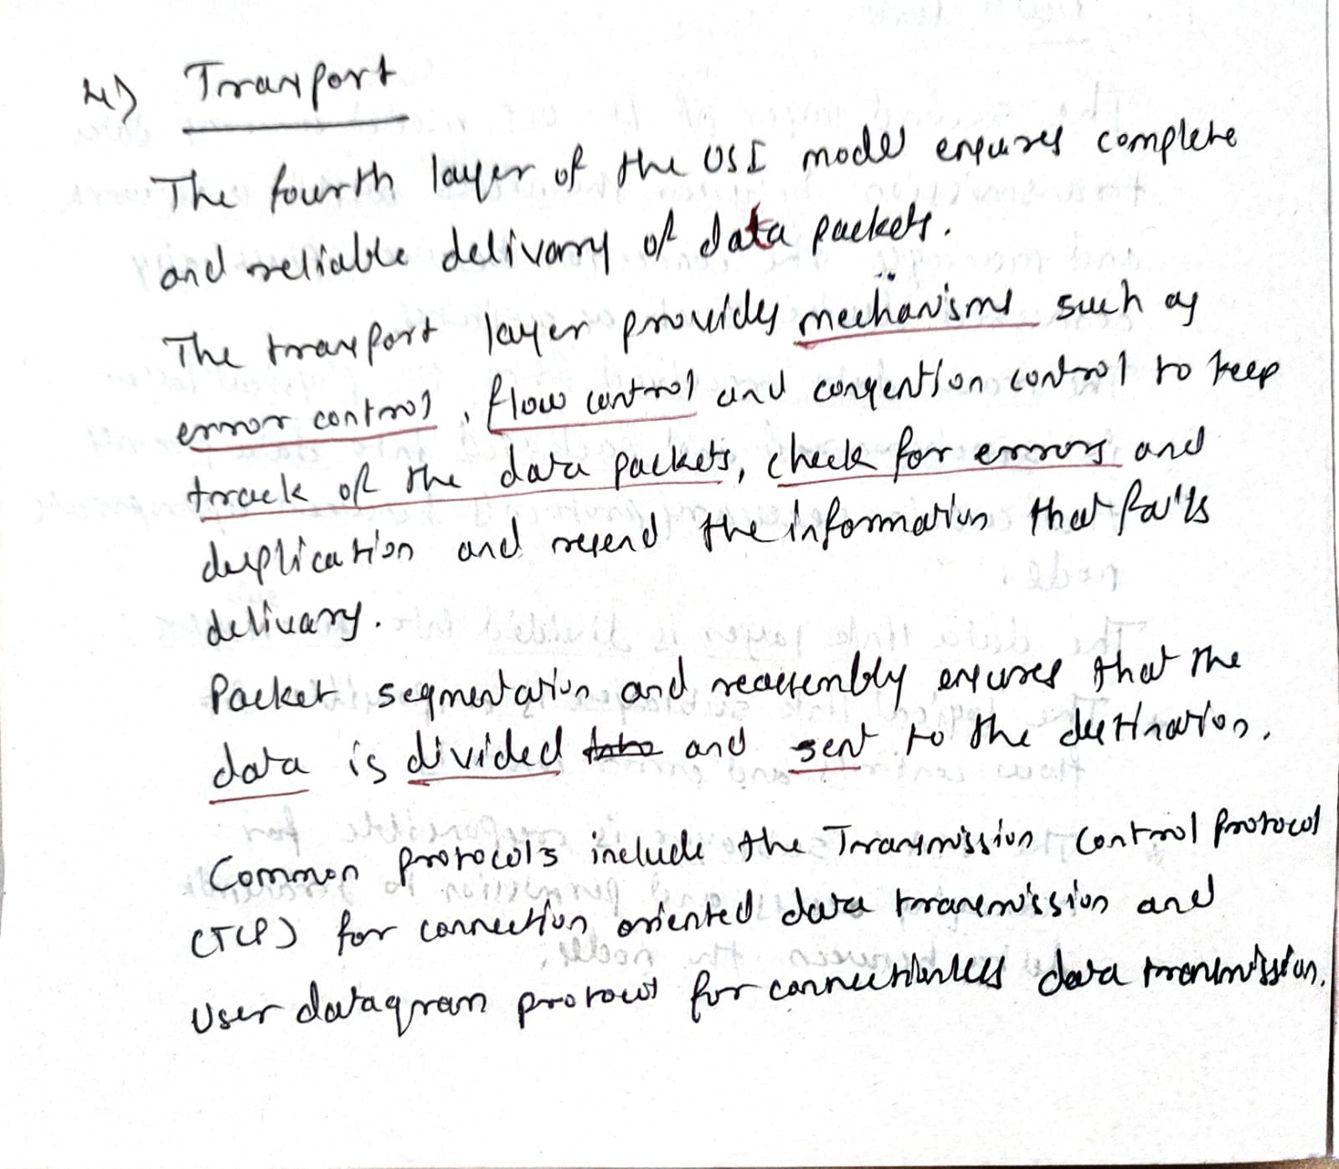

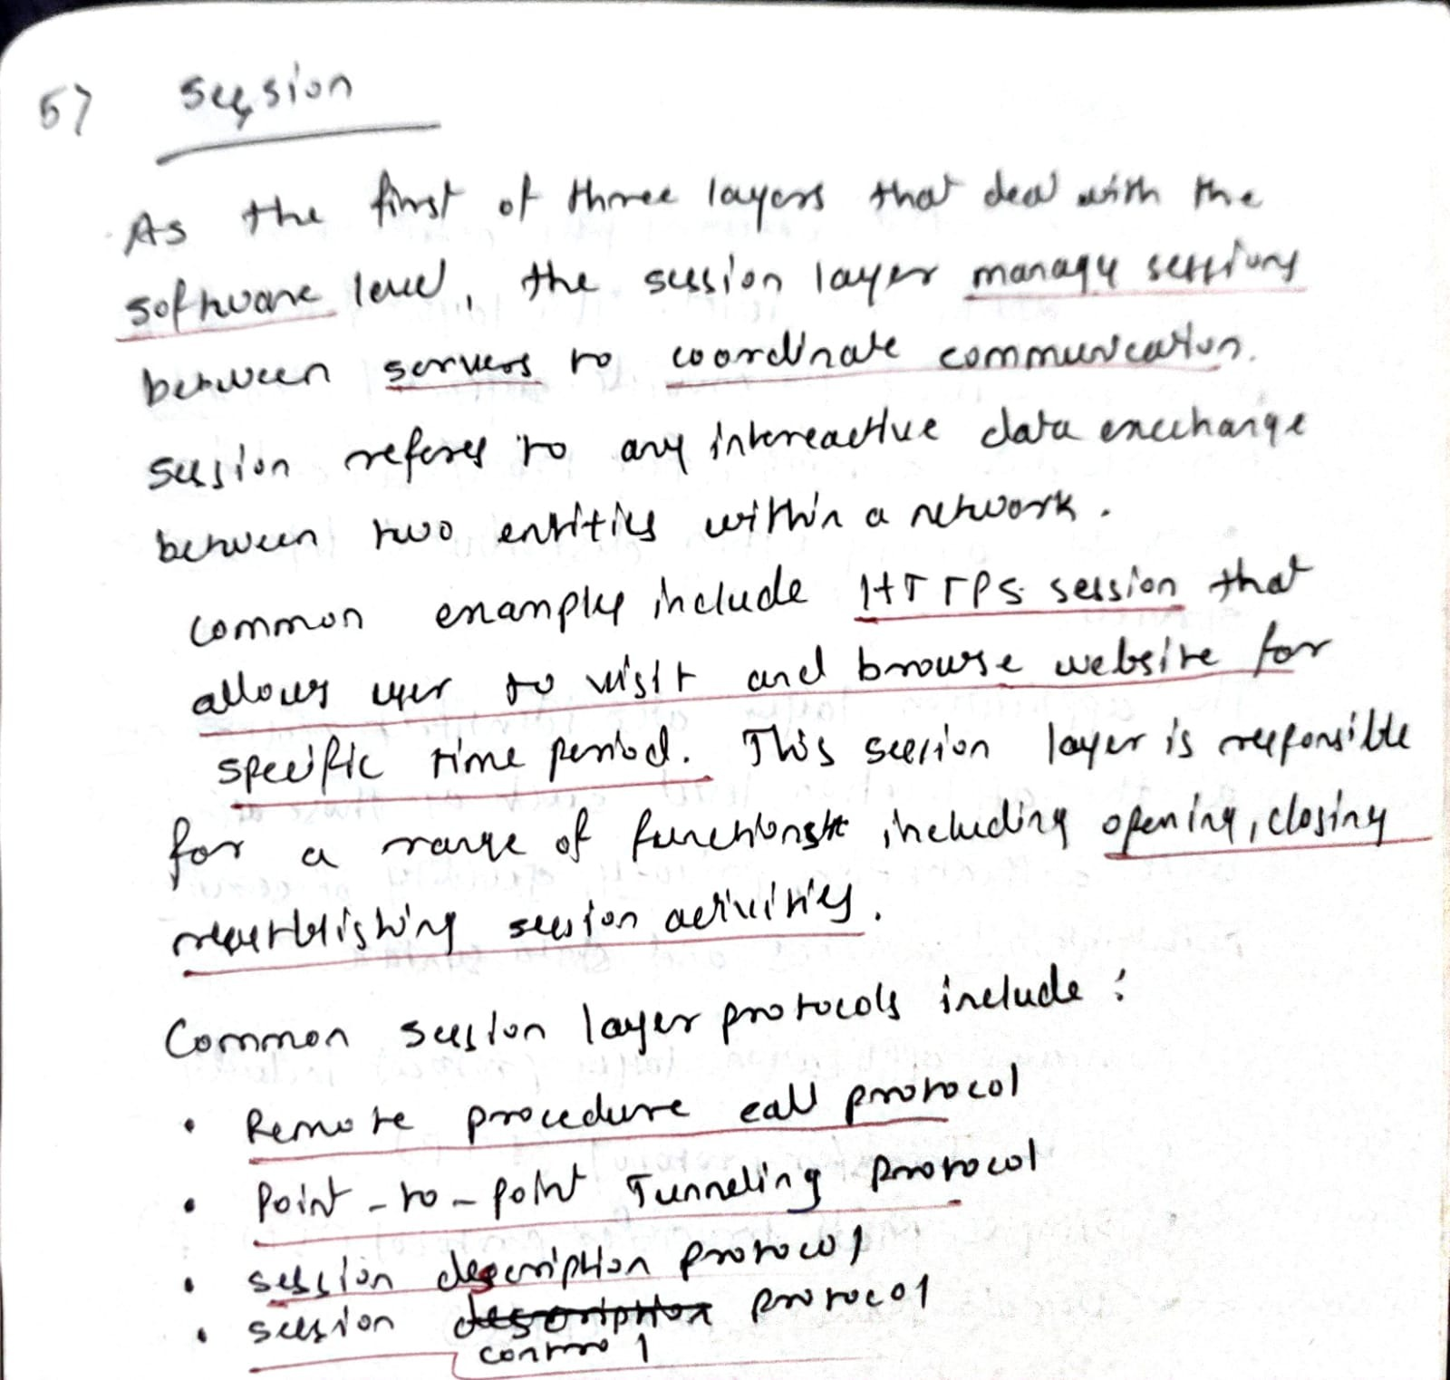

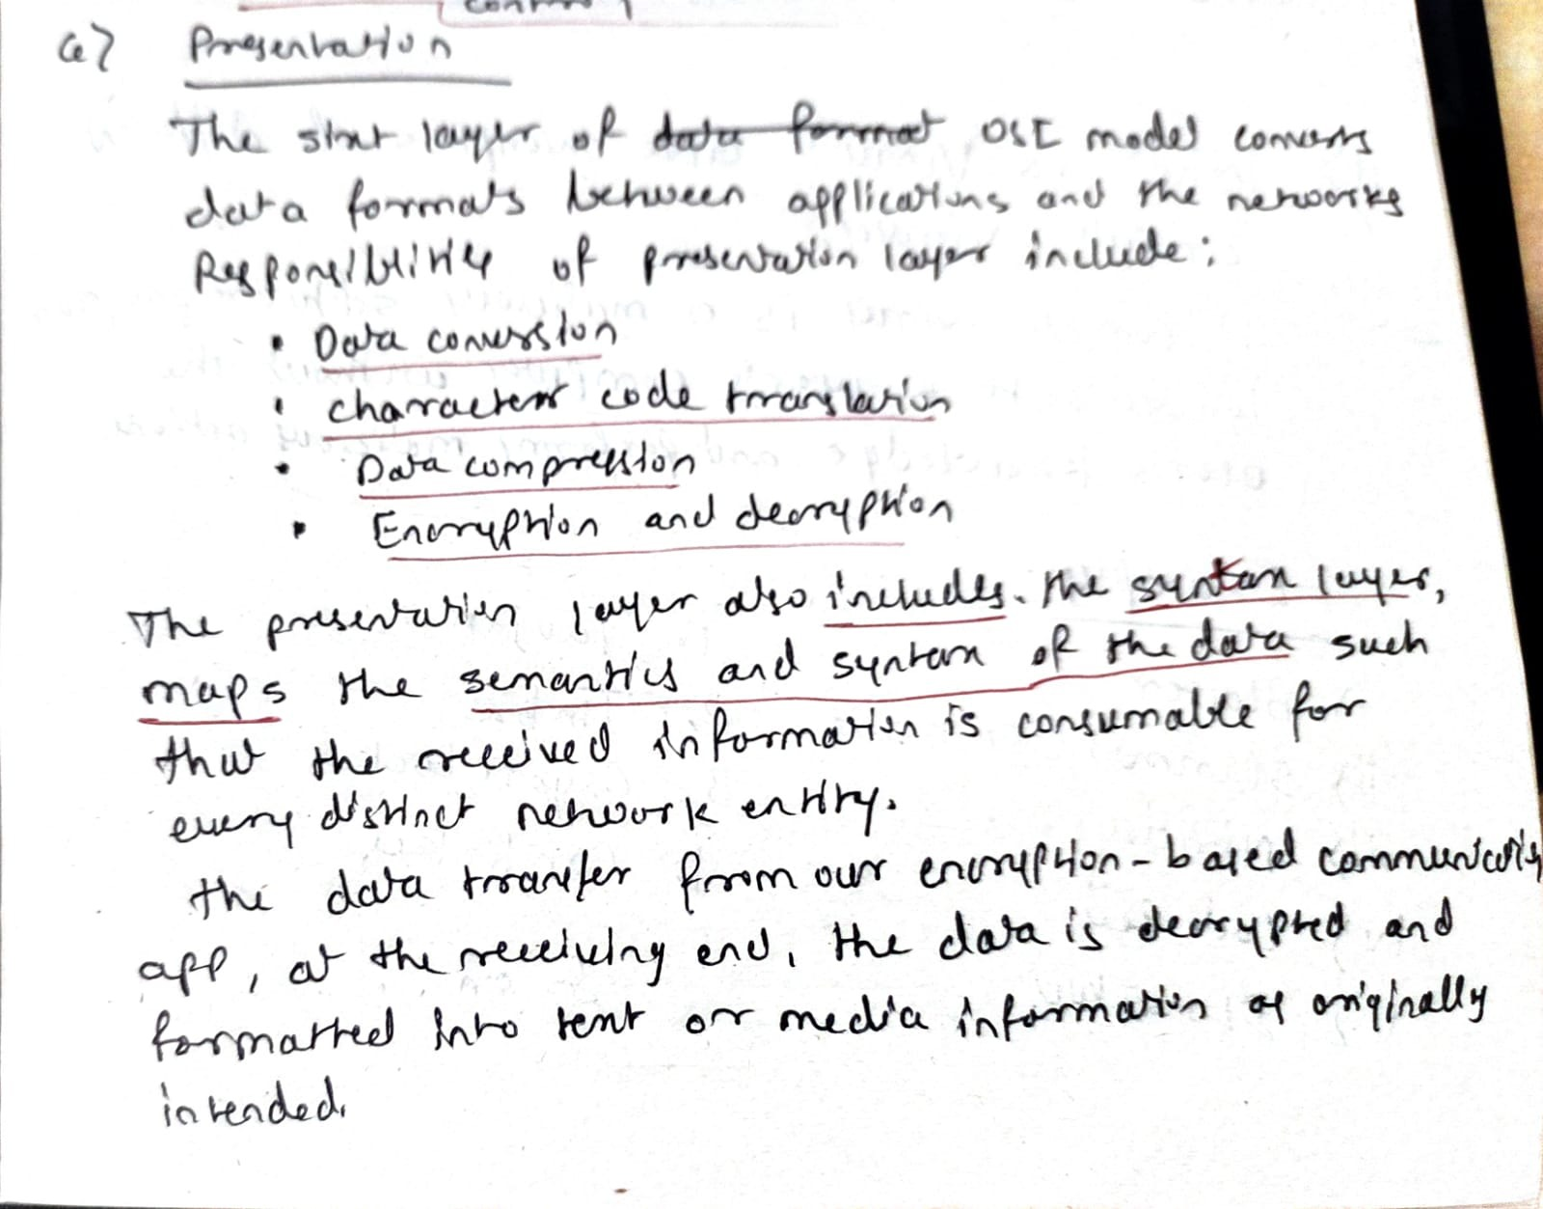

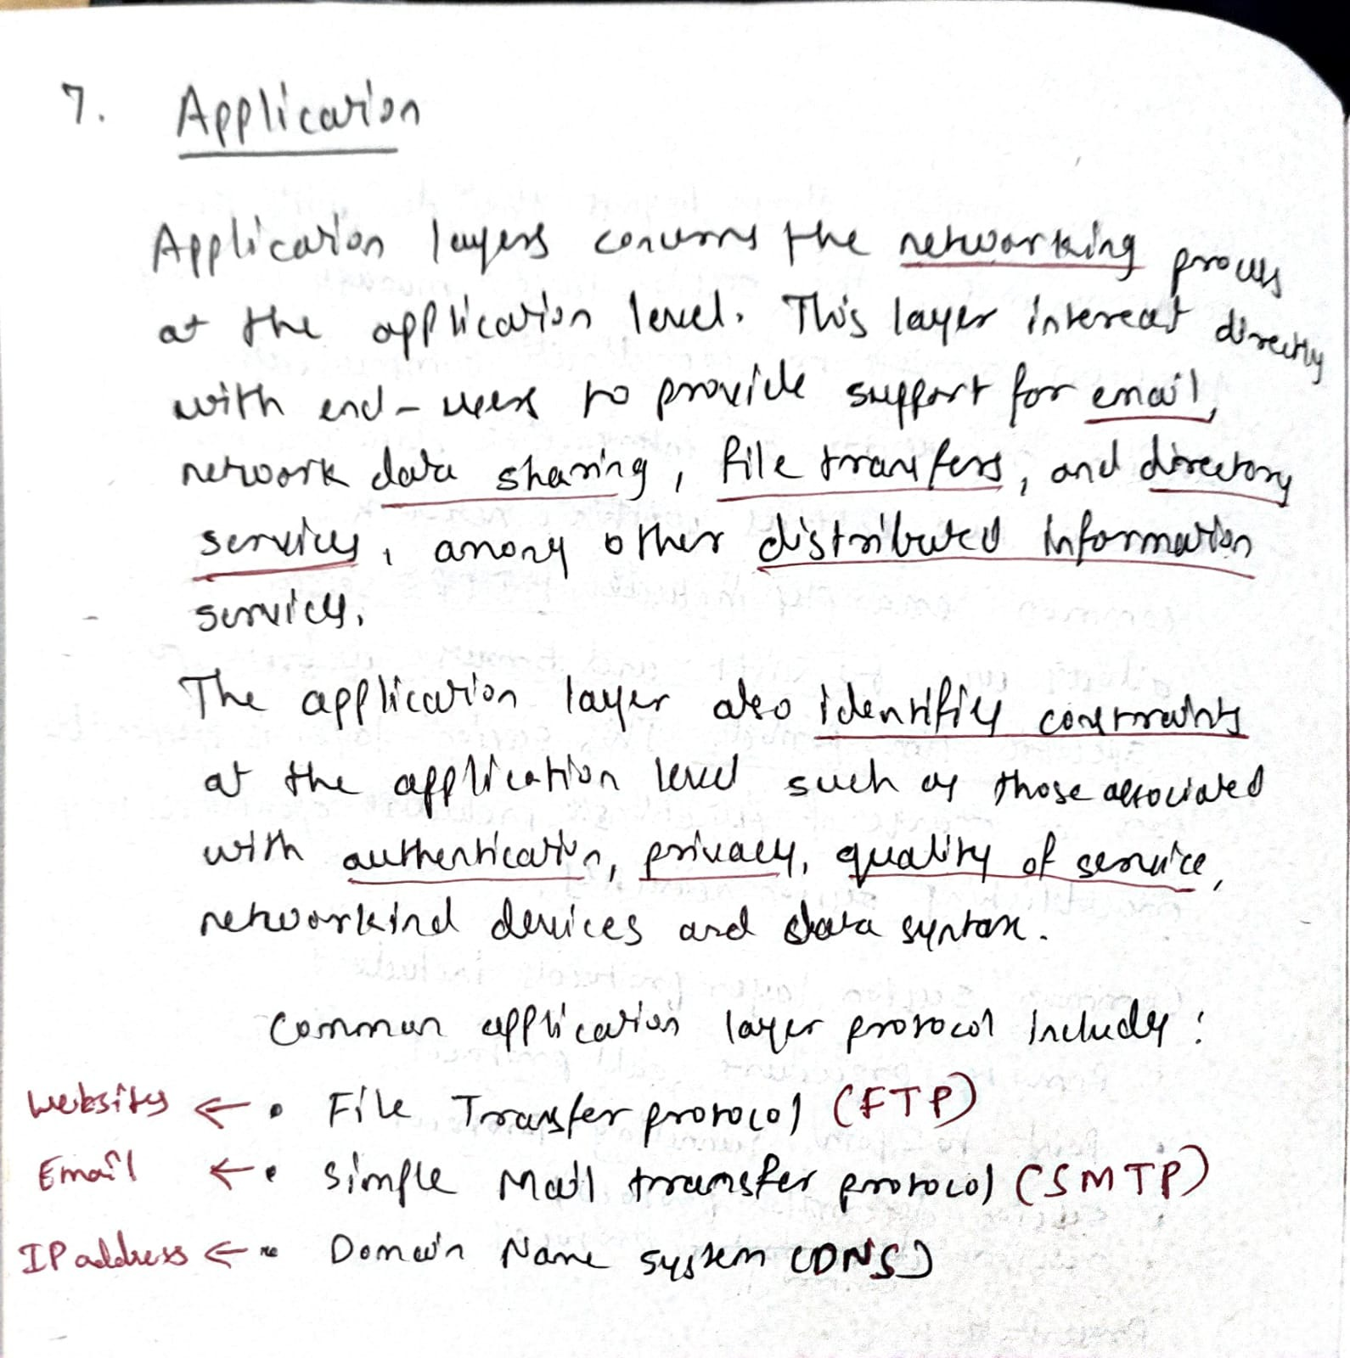

10. What is Internet Protocol Stack? Explain the services provided by

each layer

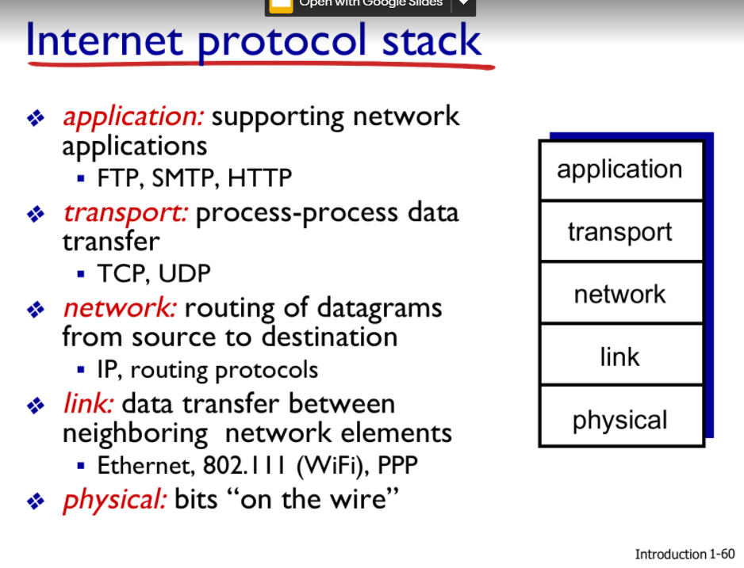

The [Internet Protocol](ftp://nic.ddn.mil/rfc/rfc791.txt) layer in the TCP/IP protocol stack is the first layer that introduces the virtual network abstraction that is the basic principle of the Internet model. All physical implementation details (ideally even though this is not quite true) are hidden below the IP layer.